**Project Report**

Chitkara University, Himachal Pradesh

**Funville**

Submitted in partial fulfilment of the requirement for the award of a Degree of

“Bachelor of Computer Application”

**Submitted To**

Department Of Computer Applications

**Submitted By**

Rahul Samanta

2213986057

**Under the supervision of**

Dr Utpal Shrivastava

Head of Department

# CERTIFICATE OF APPROVAL

The synopsis on Project entitled “Funville" have been examined by us and is hereby approved for the award of degree "Bachelor of Computer Applications (BCA)", for which it has been submitted. It is understood that by this approval, the undersigned does not necessarily endorse or approved any statement made, opinions expressed, or conclusions drawn therein but approved the Project only for the purpose for which it has been submitted.

Project Guide: Dr Utpal Shrivastava

Designation: Head of Department

**Project Details**

**Project Name:**Funvelle

**Project Title:** A Multigaming Website for Children

**Project Members: 01**

1. Student Name…………………………………, Signature…….................

Project Guide: Dr Utpal Shrivastava

Designation: Head of Department

Contents:

ProjectTitle: Funville

Certificate Of Approval: Dr Utpal Shrivastava

Project Details: A Multigaming Website for Children

1. **Introduction:** **Funville** is a vibrant multigaming website designed to provide children with a safe, engaging, and interactive platform for fun and entertainment.
2. **Background and History:**  Funville was created to provide a safe, ad-free, and engaging online gaming platform tailored specifically for children.
3. **Purpose:** The purpose of Funville is to offer children a secure, entertaining, and user-friendly platform for playing engaging online games while promoting safe digital interactions.
4. **Objective and scope of Project:** Funville ensures cross-platform compatibility, vibrant designs, and future scalability with features like educational games and multiplayer options.
5. **Technology and Domain:** Funville is developed using HTML, CSS, JavaScript, Tailwind CSS, Bootstrap, MongoDB, and design tools like Figma, Canva, and Adobe Express, hosted on Vercel.app and Render for deployment.
6. **Hardware and Software Requirement:** Funville requires a minimum of 4GB RAM, 256GB storage, a code editor (VS Code), MongoDB, and deployment on Vercel.app and Render.
7. **Feasibility Study:** Funville is technically, financially, and socially feasible, utilizing accessible web technologies and hosting platforms with a focus on safety for children.
8. **Working of Project and output:** Funville offers a secure, engaging, and user-friendly gaming experience for children, delivering a smooth, ad-free platform accessible across devices.
9. **Conclusion:** Funville successfully provides a safe, engaging, and interactive gaming platform for children, combining entertainment with security, and lays the foundation for future growth and enhancements.
10. **Suggestions for Further Work:** Add multiplayer options, educational games, user accounts, expand the game library, and implement parental controls for enhanced safety and personalization.
11. **References:** Mozilla MDN, MongoDB Docs, Tailwind CSS Docs, Bootstrap Docs, Figma, Canva, Adobe Express, Vercel and Render Docs, W3Schools.
12. **Introduction**:

In today’s digital world, providing children with a safe and engaging online experience is essential. Funville aims to meet this need by offering a secure, ad-free, and interactive multigaming platform specifically designed for children. The website features a simple, user-friendly interface and age-appropriate content, ensuring a fun yet safe environment for young users. Built with modern web technologies, Funville ensures compatibility across different devices, allowing children to enjoy their games anywhere. The platform’s goal is not only to entertain but also to provide a controlled space for children to explore, learn, and play.

1. **Background and History:**

**Funville** was created to address the need for a safe and engaging online platform for children. With the rise of digital content, the project aimed to provide a fun, ad-free gaming experience while ensuring security and ease of use. Built using modern web technologies, Funville has evolved into a child-friendly platform offering age-appropriate games, with plans for future updates and new features.

**3. Purpose:**

The primary purpose of Funville is to create a secure and enjoyable online environment for children to explore a variety of interactive games. With an increasing amount of online content available to young audiences, Funville focuses on providing a platform that is both fun and safe. The website is designed to ensure that children can enjoy gaming without encountering inappropriate content or advertisements, fostering a positive digital experience. Additionally, Funville aims to encourage creativity, problem-solving, and social interaction through games, all while prioritizing a simple, child-friendly interface that parents can trust.

**4. Objective and scope of Project:**

The main objective of Funville is to provide a safe, engaging, and user-friendly online gaming platform for children. It aims to offer a variety of interactive and age-appropriate games, ensuring a secure environment that is free from ads and harmful content.The scope of the project includes creating a simple, colorful, and intuitive interface designed specifically for children, ensuring ease of navigation. The platform will be accessible across multiple devices, including desktops, tablets, and smartphones. Additionally, the project plans to expand its game library, incorporating more games, multiplayer features, and educational content. The focus will remain on maintaining a secure environment with tailored content for young users, making Funville a trustworthy and enjoyable digital space.

# 5. Technology and Domain:

**Technology**: **Funville** utilizes web development technologies such as HTML, CSS, JavaScript, Tailwind CSS, and Bootstrap for front-end design, with MongoDB for database management. The project also makes use of design tools like Figma, Canva, and Adobe Express to create visually appealing graphics. The platform is hosted and deployed on Vercel.app and Render, ensuring reliable performance and scalability.

**Domain**: The project falls under the **Edutainment** domain, which combines educational and entertainment content, providing a safe and enjoyable gaming experience for children.

**6. Feasibility Study:**

The **Funville** project is technically feasible, as it utilizes widely available web development technologies (HTML, CSS, JavaScript) and tools (MongoDB, Vercel.app, Render) that ensure smooth functionality and scalability. The financial feasibility is also positive, as the initial development and hosting costs are low, with potential for revenue generation through safe, child-friendly features. Socially, the platform fills a gap for secure, age-appropriate entertainment for children, aligning with growing concerns around online safety. Legally, the project complies with child protection regulations, ensuring a secure and trustworthy environment for young users.

**7.** **Hardware and Software Requirement**:

**Hardware Requirement**

|  |  |
| --- | --- |
| *Sr. No.* | *Specification* |
| 1**.** | 8th Gen Intel Core i5-7300HQ processor or higher |
| 2**.** | 8 GB or more |
| 3**.** | NVIDIA GTX 1050 graphics |

**Software Requirement**

|  |  |  |
| --- | --- | --- |
| Sr. No. | Component Name | Specification |
| 1 | *GPU* | Tesla T4 graphic card |
| 2 | *Extended RAM* (in Colab) | 25GB |
| 3 | *Extra storage (in colab)* | 350 GB |
| 4 | *IDE* (provided by colab) | Jupyter notebook |
| 5 | *Framework* | VS Code |
| 6 | *Programming language* | JavaScript |

**8. Working of Project and output:**

**Funville** operates as an interactive and secure gaming platform designed specifically for children. The platform allows users to access a variety of age-appropriate games, each offering engaging content that promotes fun, creativity, and cognitive development. The website’s interface is simple, vibrant, and easy to navigate, ensuring that children can independently explore and enjoy the games without difficulty.

Behind the scenes, the platform is built using modern web technologies such as HTML, CSS, JavaScript, and MongoDB, which ensure a smooth and responsive experience across various devices, including desktops, tablets, and smartphones. Funville prioritizes safety by offering an ad-free environment and carefully curating content to ensure it aligns with appropriate standards for children.

The output of this project is a secure, engaging, and user-friendly gaming platform that provides children with hours of entertainment in a safe and controlled environment. The platform ensures a consistent and enjoyable experience, whether accessed on a computer or mobile device, and aims to continuously grow by expanding the game library and adding new features, such as multiplayer games and educational content.

**9. Conclusion:**

In conclusion, Funville successfully addresses the need for a safe, interactive, and engaging online gaming platform for children. By combining secure, age-appropriate content with a user-friendly interface, the platform ensures that children can enjoy entertainment in a controlled and protected environment. The project not only offers a fun experience but also prioritizes safety, making it a trusted space for young users. As the platform continues to evolve with new games and features, it lays a strong foundation for future growth, positioning itself as a go-to destination for children’s online gaming.

**10. Suggestions for Further Work:**

To enhance Funville and expand its offerings, several improvements can be made. Firstly, integrating multiplayer functionality would allow children to interact and collaborate with friends or other users, fostering social skills. Additionally, incorporating educational games that combine fun with learning could add value to the platform, making it not only entertaining but also educational.Further work can also focus on implementing customizable user profiles where children can track their progress, set game preferences, and earn rewards. Adding parental control features would allow parents to monitor their child’s activity and ensure content appropriateness. Expanding the game library with more diverse genres, such as puzzle games or story-driven adventures, would keep the platform fresh and engaging. Lastly, improving the platform’s accessibility with multi-language support could make it accessible to children worldwide, enhancing its global reach.

**11**. **References:**

* 1. Mozilla Developer Network (MDN). "HTML5 and JavaScript for Beginners". <https://developer.mozilla.org/en-US/docs/Web/HTML>
  2. W3Schools. "CSS Tutorial". https://www.w3schools.com/css/
  3. MongoDB Documentation. "MongoDB Basics". <https://mongodb://localhost:27017/>
  4. Figma. "Figma Design Tools". <https://www.figma.com/>
  5. Vercel Documentation. "Deploying on Vercel". https://rahul-funville.vercel.app/
  6. Render Documentation. "Getting Started with Render". <https://render.com/docs>

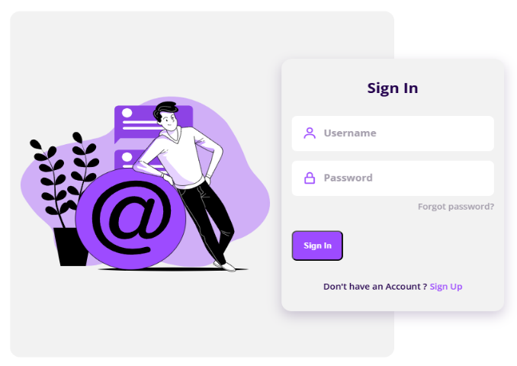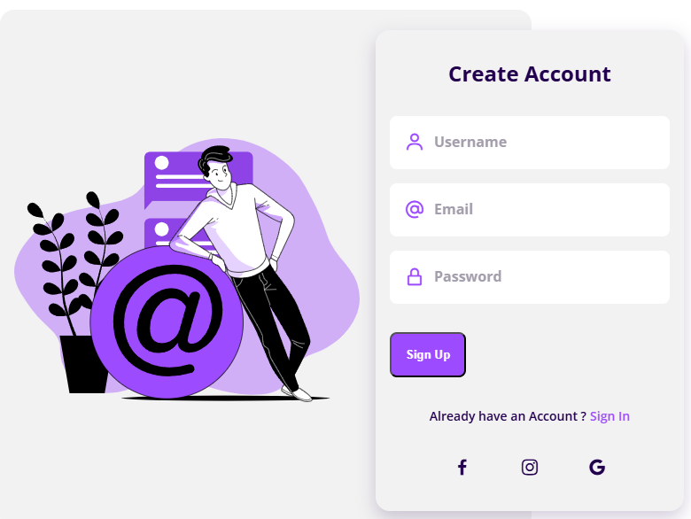

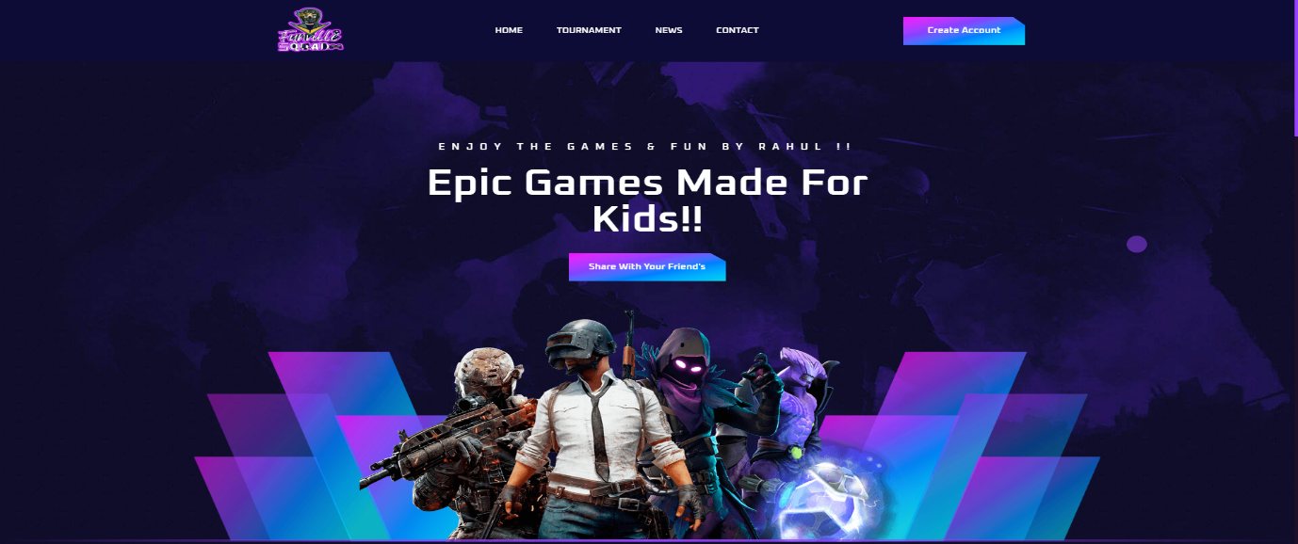

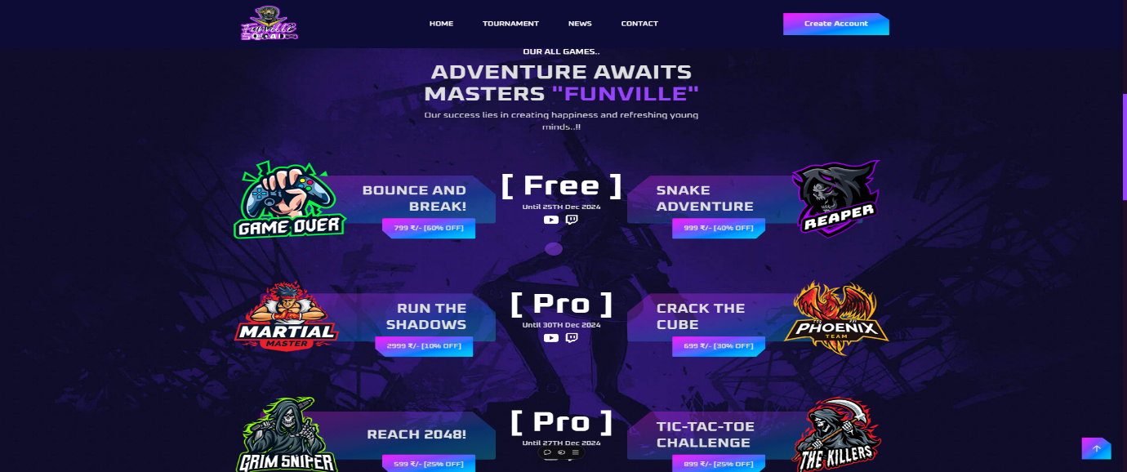

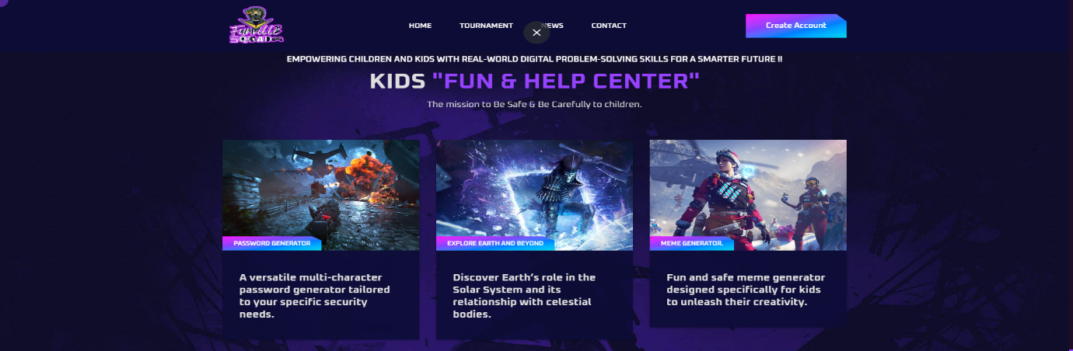

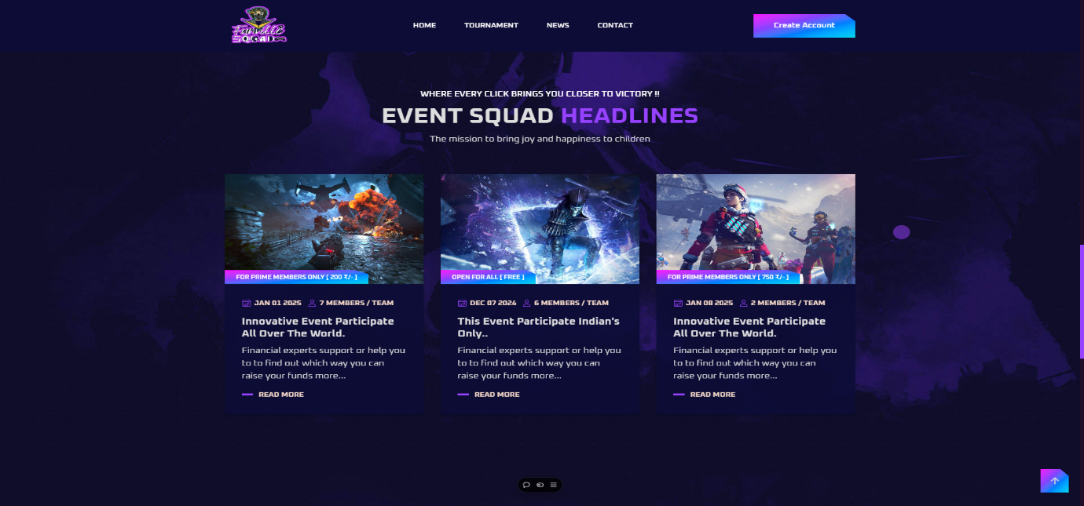

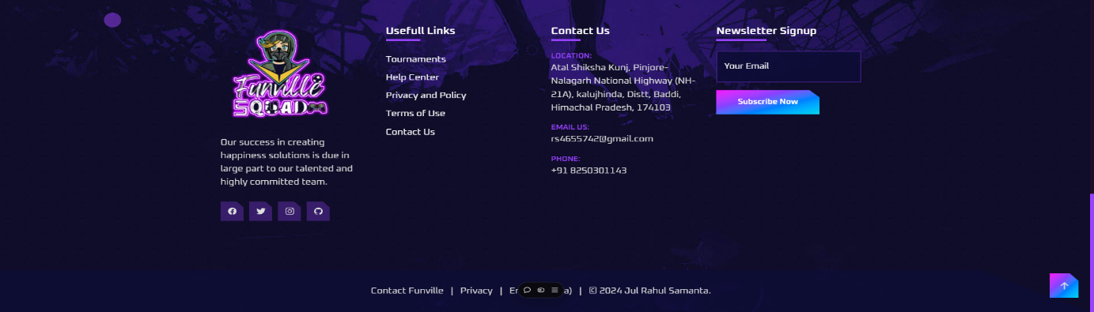

**GAME’S**

